Required Coding Activity 14.2: Developing a Web Application in Java

Objective
Build and deploy a simple Spring Boot web application inside a Docker container, then verify that it responds to browser requests.
Step 1: Create the Java Docker Container
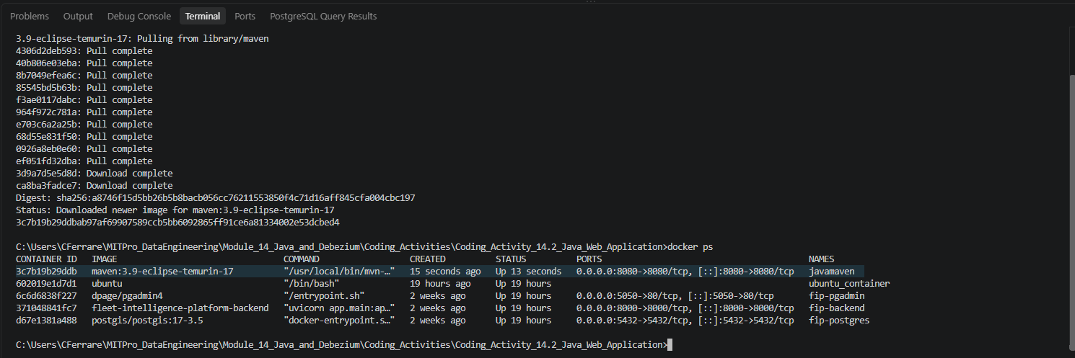

Step 2: Open the Container CLI
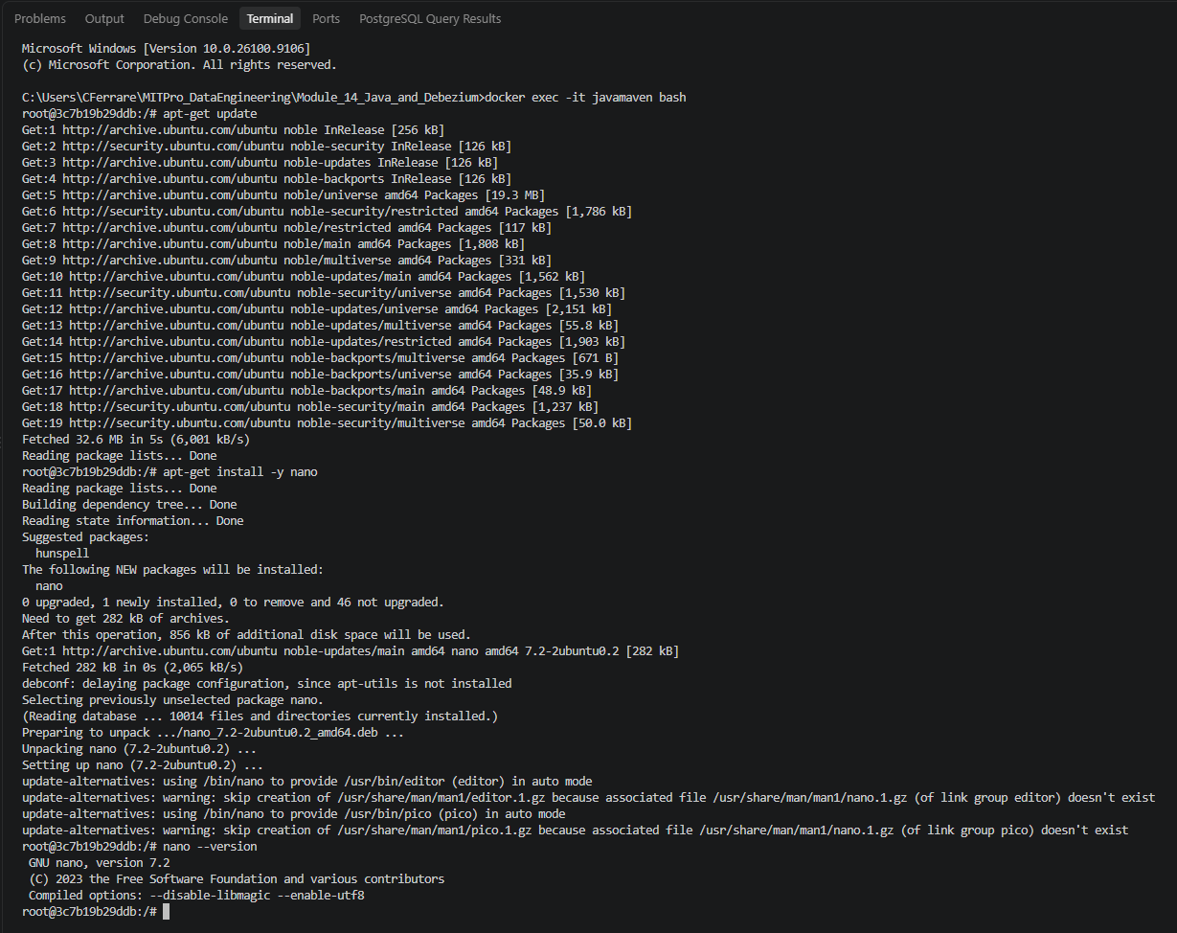

Step 3: Create a Spring Boot Project
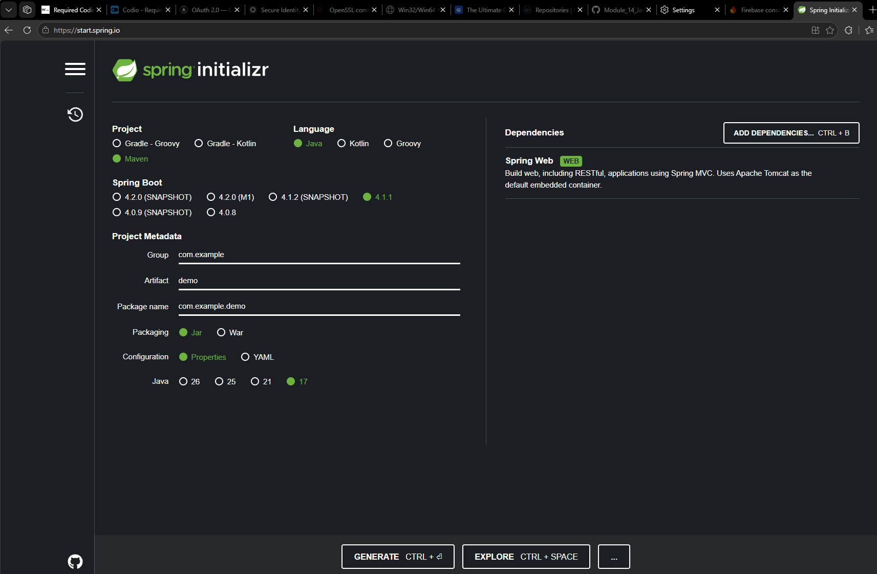
Step 4: Extract demo.zip
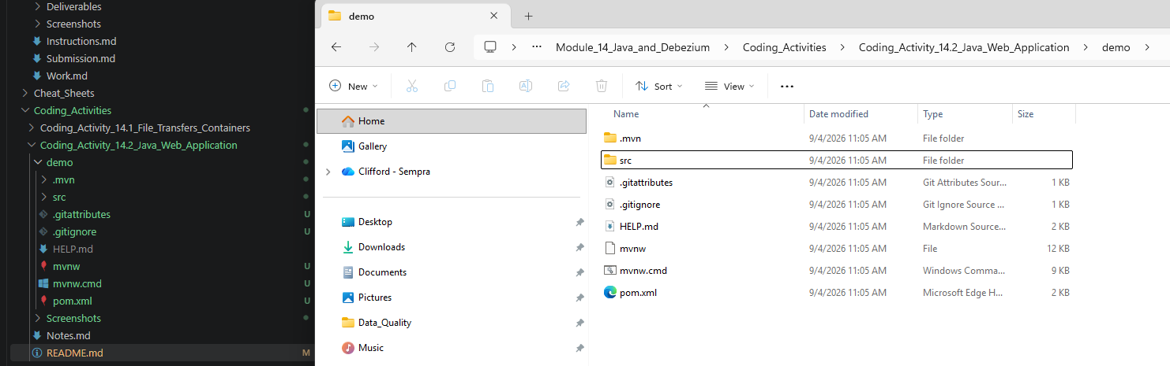

Step 5: Navigate to the Project Folder
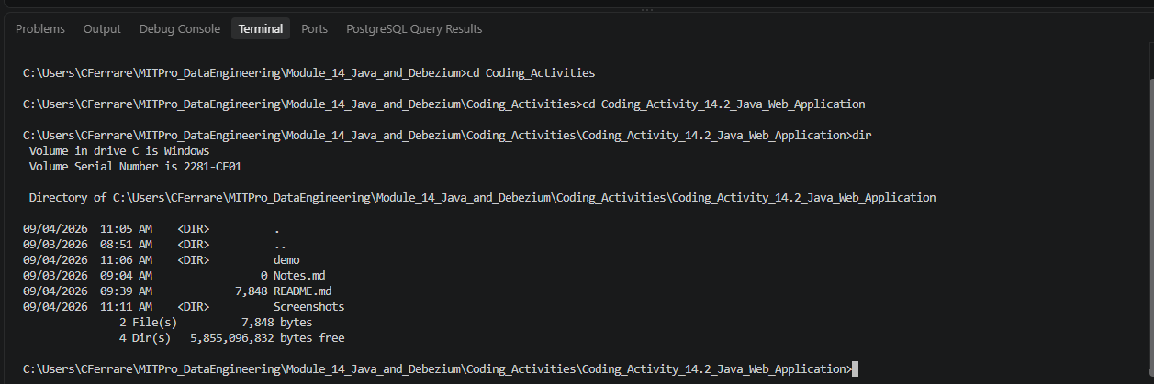

Step 6: Upload Project to the Container
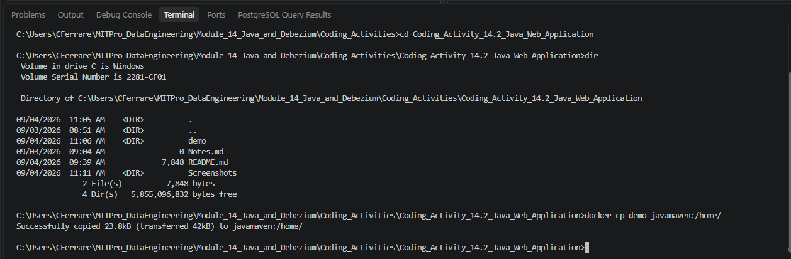

Step 7: Verify Upload
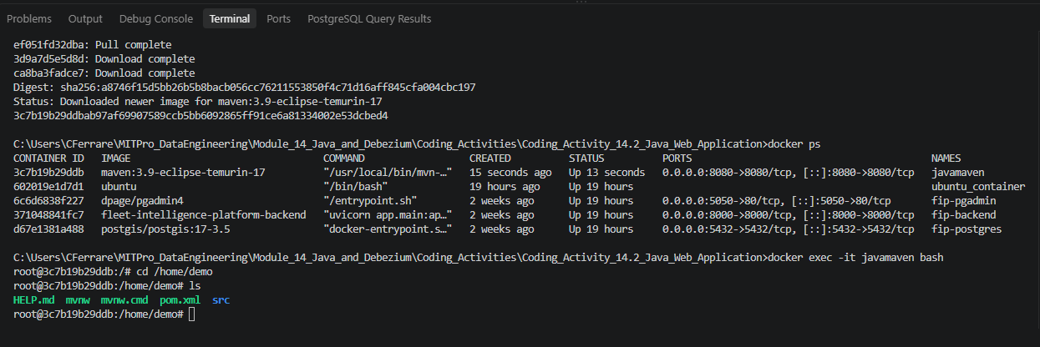

Step 8: Locate DemoApplication.java
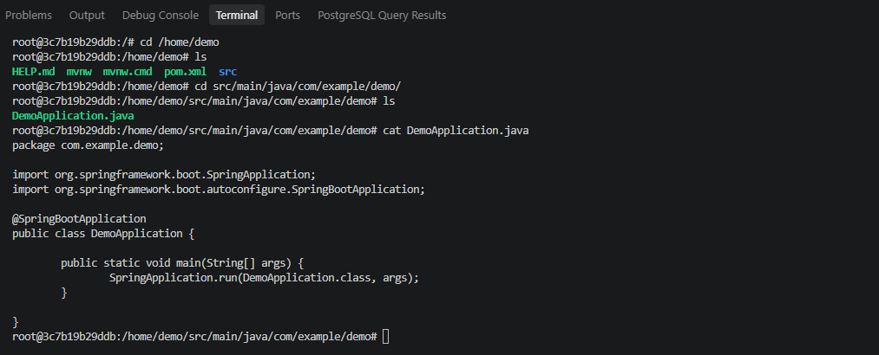

Step 9: Update DemoApplication.java
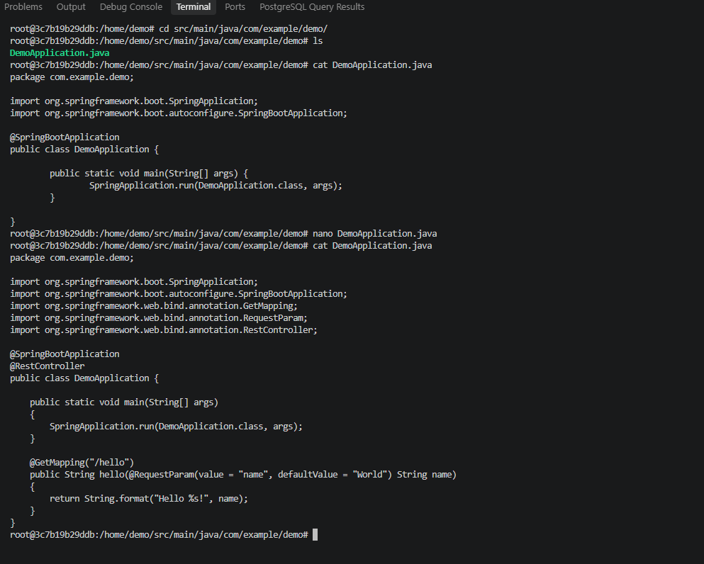

Step 10: Run the Spring Boot Application

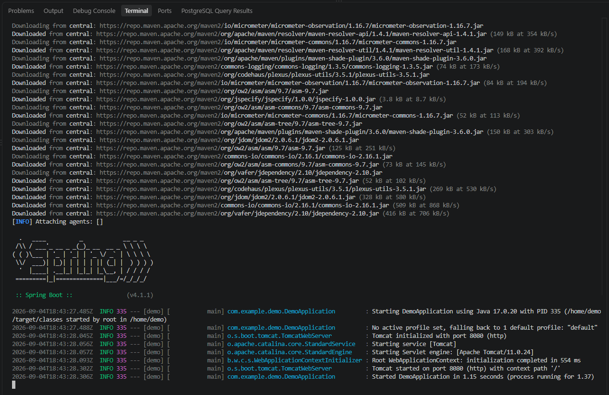

Step 11A: Test the Application
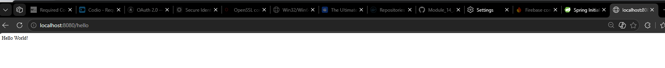
Step 11B: Test URL Parameter
